Sourabh Mina

Sourabh2002wow@gmail.com

Finlatics Detailed Research report

Research Insights

IndusInd Bank Ltd

**GENERAL OVERVIEW:**

IndusInd Bank is a universal Bank with a widespread banking footprint with over 2.5 crore customers, over 5,000 distribution points and nearly 2,000 branches across the country. Established in 1994 by Srichand P Hinduja, the name ‘IndusInd’ Bank was inspired by the Indus Valley Civilisation - one of the greatest cultural examples of a combination of innovation with sound business and trade practices. IndusInd Bank has 2,015 Branches/Banking Outlets and 2,886 ATMs spread across 760 geographical locations of the country. The Bank also has representative offices in London, Dubai and Abu Dhabi. IndusInd Bank was included in the NIFTY 50 benchmark index on April 1, 2013.

20,000.00 40,000.00 60,000.00 80,000.00 100,000.00 120,000.00 140,000.00 2020 2019 **SHAREHOLDING PATTERN OF TATA CONSULTANCY SERVICES LIMITED** 2018 2017-Institutions Mutual Funds/UTI Govt. FII

**Description Percent of Share (%)**

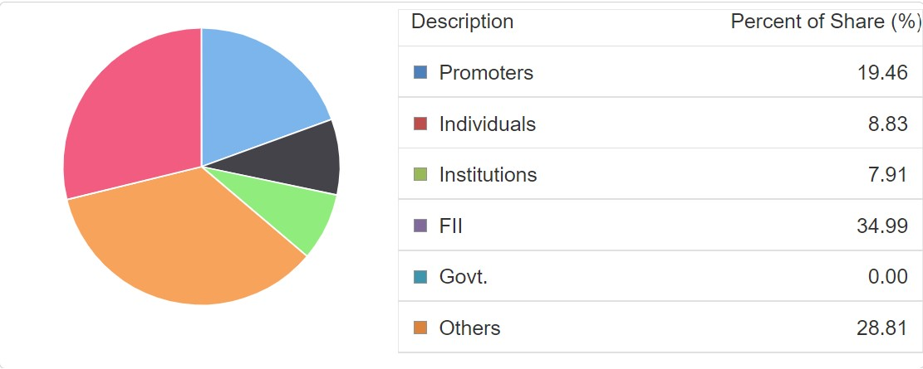

#### On the basis of the above information, it is very clear that **IndusInd Bank Ltd**

is a **professionally operated business** rather than family operated as Investors and promoters holds more than 50% of their capital.

Financial Performance report over 2019-21

|  |  |  |  |  |  |
| --- | --- | --- | --- | --- | --- |
| **Properties/Year**  **(In Crs)** | **2021** | **2020** | **2019** | **2018** | **2017** |
| Sales Turnover | 28999.80 | 28782.83 | 22261.15 | 17280.75 | 14405.67 |
| Other Income | 6558.6120 | 6951.3095 | 5646.7189 | 4750.1033 | 4171.4922 |
| **TOTAL INCOME** | **35558.41** | **35734.14** | **27907.87** | **22030.85** | **18577.16** |
| **Profit and Loss for the Year** | **2836.39** | **4417.91** | **3301.10** | **3605.99** | **2867.89** |

**SWOT ANALYSIS**

SWOT analysis is a structured approach to evaluate a company’s strategic position by analysing its strengths, weaknesses, opportunities, and threats. It is a simple technique to analyse the outcomes of a marketing evaluation. The SWOT analysis of INDUSIND BANK LTD are as follows:

## 

### Strengths of IndusInd Bank

Strengths are an organization’s distinct skills that offer it a competitive edge in gaining greater market share, attracting more customers, and maximising profitability. INDUSIND BANK LTD’s strengths are listed below:

* **Strong reputed Brand Image in the market –**INDUSIND BANK LTD has unquestionably created its own brand, image, and reputation; it keeps its consumers satisfied and acts as a sign of excellence.
* **Well established strategic alliances –** INDUSIND BANK LTD has formed significant alliances with multinational companies all around the world. It collaborated with technology powerhouses such as Amazon, Adobe, Dell, Bosch, and HP, among others. Through these partnerships, INDUSIND BANK LTD provides both technologically viable and creative commercial and tactical solutions.
* **Robust Service Portfolio –** INDUSIND BANK LTD has a diverse service offering that includes application development and maintenance of Business Process Services (BPS), IT infrastructures, business intelligence, and more. A robust and diversified portfolio is drawn to various corporate clients.
* **Empowered and encouraged employees –**Through effective training and learning initiatives, a highly competent workforce has been created. INDUSIND BANK LTD invests heavily in employee training and development, resulting in a staff that is not just highly competent but also driven to achieve greater success.
* **Excellent returns on capital invested –**INDUSIND BANK LTD has an excellent track record of executing new projects and generating good returns on capital expenditure by establishing new income streams.

### 2. Weaknesses of INDUSIND BANK LTD

Weaknesses are elements of a company or brand that need to be improved. The following are INDUSIND BANK LTD’s significant flaws:

* **Performance of current share pricing–**  The current pricing of the stock has been decreasing over a rumour between the company share holders
* **Legal Squabbles –**INDUSIND BANK LTD filed a lawsuit against Epic System in 2014 for suspected abuse of private information. INDUSIND BANK LTD was found guilty in 2016 and was charged $940 million in damages. INDUSIND BANK LTD objected to and rejected the higher competence’s decision. Such incidents have a negative impact on the company’s image.
* **The product segment is not relatively impressive –**While INDUSIND BANK LTD does well by delivering the greatest services, its products aren’t what one would anticipate from a company of its kind. They do require some effort.

### 3. Opportunities for INDUSIND BANK LTD

Opportunities are possible areas of emphasis for a firm to focus on in order to enhance outcomes, boost sales, and, eventually, profit.

* **Emerging Interest in Cloud Computing –** Digital technologies and high-speed internet access have evolved. In fact, spending on cloud services will rise at a CAGR of 19% over the next five years. Society is shifting towards cloud-based solutions. INDUSIND BANK LTD has a robust cloud-based infrastructure and is thus prepared to capitalise on the created demand.
* **M2M Solutions –**Wireless and cable communications systems are both enabled by Machine to Machine (M2M) solutions. There are bright possibilities for M2M solutions in the future, and revenues are projected to be substantial. INDUSIND BANK LTD offers a comprehensive variety of M2M services, allowing the need for M2M solutions to be met.
* **Transformation of the Digital Universe –**Because the world is becoming more digital, business forces are altering the digital economy. INDUSIND BANK LTD’s primary goal is to digitally transform and deliver digital solutions. INDUSIND BANK LTD could expect more expenditure on technology for digital transformation.
* **Solutions for mobility –** With a rising mobile worker population and the increased usage of sophisticated mobile devices, enterprise mobility solutions are expected to be driven by business applications. The demand for mobility solutions is latent and is expected to grow at a CAGR of 24.7 per cent through 2022. INDUSIND BANK LTD is well-positioned to profit from its increased emphasis on the development of enterprise mobility solutions.

### 4. Threats to INDUSIND BANK LTD

Threats are environmental elements that might have a negative impact on a company’s success. INDUSIND BANK LTD’s threats include the following:

* **Competition is fierce –**Banking firms such as SBI, PNB, ICICI, HDFC, Kotak Mahindra Bank and others confront fierce rivalry. As a result, the industry is experiencing price wars and has a restricted market share.
* **A high rate of attrition –**The Indian banking sector has a high rate of turnover, which raises the expense of providing new workers with skills and leadership development and has a negative impact on the company’s reputation.
* **The Constraints on Immigration –**With immigration regulations, increasing H-1B visa fees, and changing political situations in the US, Indian banks are anticipated to suffer as they increase their costs and damage profitability, posing a risk to the sector.

Competitive Analysis:

IT firms such as Infosys, Wipro, Capgemini, Deloitte, Accenture, and others confront fierce rivalry, which results in restricted market shares and price wars between the same companies.

Also with large MNC’s trying to expand into Indian Technological markets such as Google and Microsoft, it makes it rough competing in the same market levels resulting in inflations/deflation of share prices, brand products and availability of resources to the customers.

## **Conclusion**

INDUSIND BANK LTD is unquestionably the best in its industry. It has numerous and noteworthy strengths. For a company like INDUSIND BANK LTD with such a great brand image, brand backing, market command, portfolio, reach, and so on, it needs just a little more work to address its weaknesses and be more alert to threats. If INDUSIND BANK LTD pays more attention to its strengths and expands as well as adjusts even further for new opportunities, INDUSIND BANK LTD will be able to keep its crown.

We also discovered in this SWOT Analysis of INDUSIND BANK LTD that the firm is significantly reliant on its customers and has great brand recognition and trust. Considering the rising competition in a competitive field like Banking, firms have to compete for their customers through improved marketing efforts.